**Documentation for WS2812B Led**

**Objective:**

To replicate the status LED behaviour of the Here3+ GPS module on an external WS2812B LED matrix for enhanced visibility or custom enclosure integration.

**Hardware Configuration:**

* Flight Controller: Cube Orange+
* GPS Module: Here3+ (connected via CAN)
* External LED Module: WS2812B 4x4 RGB LED Matrix
* Microcontroller: Not used — LED driven directly from Cube Orange plus through AUX port
* Power Source: External 5V BEC
* Voltage Protection: 1N4007 diode in series with VCC line

**Wiring Details:**

Cube Orange+

AUX 5

**GND**

**VCC**

**SIGNAL**

**GND**

**VCC**

**DIN**

WS2812B

IN4007 Diode

+VE -VE

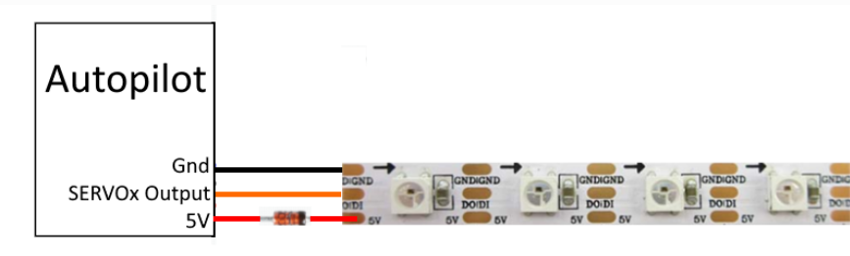

**Electrical Considerations:**

* **1N4007 diode** is used in series with the VCC line to **step down 5V to ~4.3V**, which is within the safe operating range for the WS2812B LED module.
* An **external BEC** ensures a stable 5V power supply, avoiding power fluctuations from the flight controller's internal regulators.
* The **WS2812B data line** is directly driven from the Cube Orange+ AUX 5 signal pin.

**Software:**

* The Cube Orange+ outputs **PWM signals on AUX 5** configured to control the WS2812B LED.
* The LED patterns **mimic the Here3+ GPS LED statuses** — including GPS lock, no lock, arming status, and failsafes according to ArduPilot system indicators.

**Parameters:**

NTF_LED_TYPES:123367

NTF_LED_LENGTH:16

SERVO13_FUNCTION:120

**Led Definition:**

| **LED Pattern** | **Meaning** |
| --- | --- |
| Flashing Red and Blue | Initializing gyroscopes. Hold vehicle still and level. |
| Flashing Blue | Disarmed, no GPS lock. |
| Solid Blue | Armed, no GPS lock. |
| Flashing Green | Disarmed, GPS lock acquired (ready to arm). |
| Fast Flashing Green | Disarmed, GPS lock acquired with SBAS. |
| Solid Green | Armed, GPS lock acquired – ready to fly. |
| Double Flashing Yellow | Pre-arm check failure – system will not arm. |
| Single Flashing Yellow | Radio failsafe activated. |
| Flashing Yellow | Battery failsafe activated. |
| Flashing Yellow and Blue | GPS glitch or GPS failsafe activated. |
| Flashing Red and Yellow | EKF or Inertial Navigation failure. |
| Flashing Purple and Yellow | Barometer glitch detected. |
| Solid Red | Critical error (e.g., SD card, MTD, or IMU sensor failure). |
| Solid Red | SD card missing or unreadable (e.g., bad format or corruption). |
| No Light | No firmware detected or firmware corrupted. |

**Conclusion:**

The WS2812B LED module successfully mimics the Here3+ GPS status LED when powered and signaled via the Cube Orange+ AUX 5 port. The use of a 1N4007 diode to drop the VCC to ~4.3V ensures reliable and safe operation of the LED matrix.